Illustrated assembly (draft – work in progress)

Mount sensors

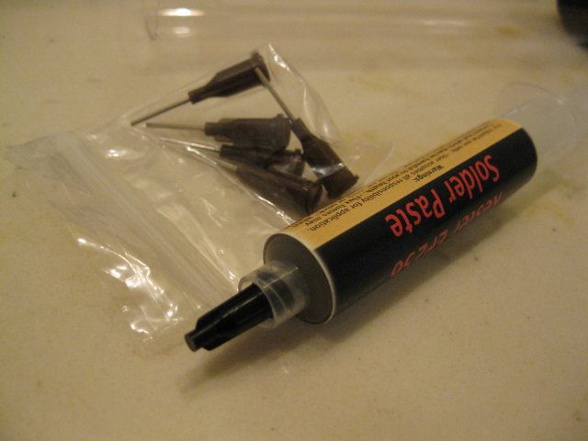

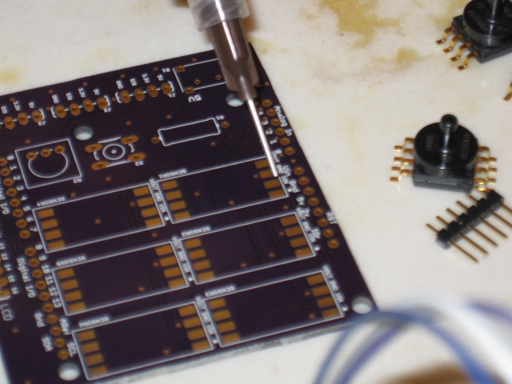

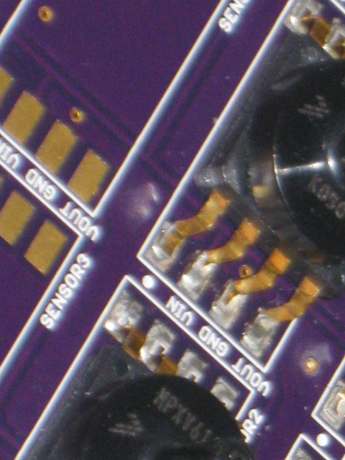Illustration 1: Align notch on sensor to dot on board

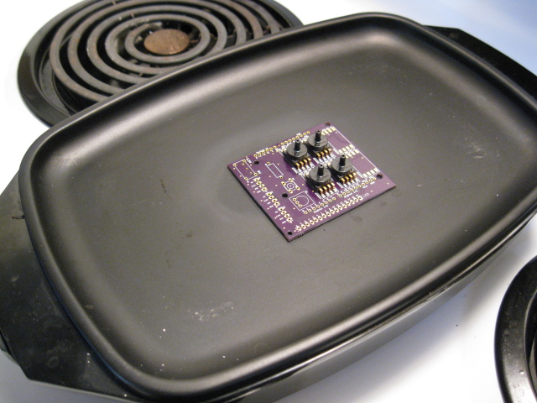
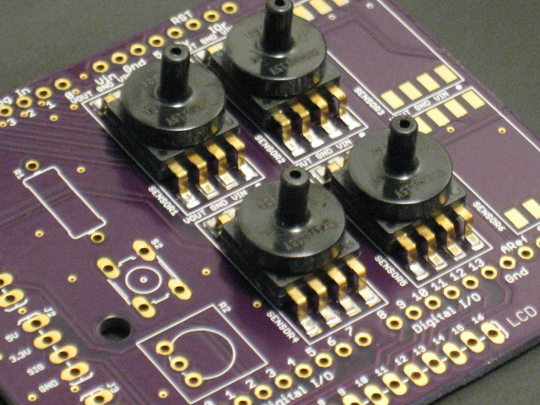Illustration 2: Let it cool before moving

Mount switches and resistor

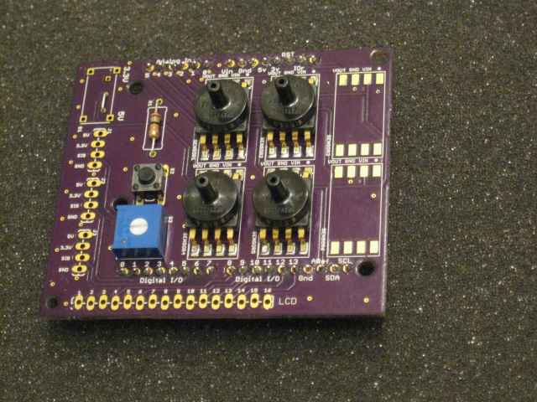

Mount LCD

Mount headers

Mount power selector

